**Question 2**

Create a table called Employee that contain attributes EMPNO, ENAME, JOB, MGR, SAL & execute the following.

1. Add a column commission with domain to the Employee table.

2. Insert any five records into the table.

3. Update the column details of job

4. Rename the column of Employ table using alter command.

5. Delete the employee whose Empno is 105.

**Solution:**

CREATE TABLE Employee_new (

EMPNO INT,

ENAME VARCHAR (50),

JOB VARCHAR (50),

MGR INT,

SAL DECIMAL (10, 2),

);

DESC Employee;

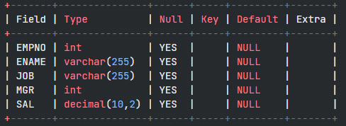

1. Add a column commission with domain to the Employee table.

ALTER TABLE Employee

ADD COLUMN COMMISSION DECIMAL (10, 2);

DESC Employee;

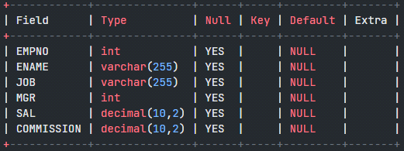

2. Insert any five records into the table.

INSERT INTO Employee (EMPNO, ENAME, JOB, MGR, SAL, COMMISSION)

VALUES

(101, 'Radha Bai', 'Manager', NULL, 5000.00, 1000.00),

(102, 'Krishna Kumar', 'Developer', 101, 4000.00, NULL),

(103, 'Abdul Sattar', 'Salesperson', 102, 3000.00, 500.00),

(104, 'Bob Johnson', 'Accountant', 101, 4500.00, NULL),

(105, 'Amartya Sen', 'HR Manager', 101, 4800.00, 800.00);

SELECT * FROM Employee;

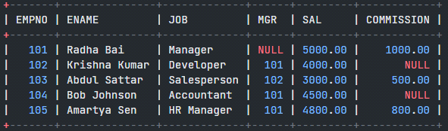

3. Update the column details of job

UPDATE Employee

SET JOB = 'Senior Developer'

WHERE EMPNO = 102;

SELECT * FROM Employee;

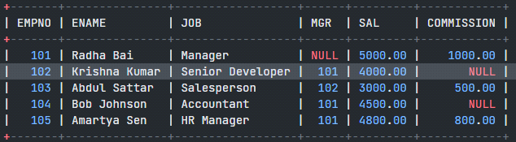

4. Rename the column of Employ table using alter command.

ALTER TABLE Employee

CHANGE COLUMN MGR MANAGER_ID INT;

DESC Employee;

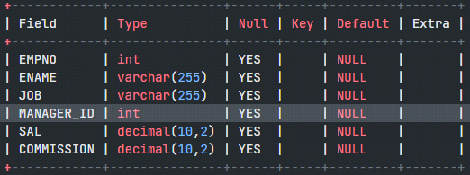

5. Delete the employee whose Empno is 105.

DELETE FROM Employee

WHERE EMPNO = 105;